Report Skeleton

## Summary

* Provide a high-level summary of the project, including motivation, key results, and contributions
* Describe the problem attempted to solve, approach, and what is accomplished/learned
* Aim this section at a general audience with basic mathematical literacy, but no specific knowledge of statistics, machine learning, or computational linguistics

## Data

* Update and expand discussion of the data, including:
  + Where the data comes from
  + Domain and format of the data
  + Preprocessing and wrangling performed
  + Amount of data accessed
  + Annotations and how they were performed
* Break discussion into subsections as necessary

## Methods

* Update and expand discussion of the methods, including:
  + How we solved the problem
  + Implementation of algorithms or off-the-shelf tools
  + Workflow and design of the system
  + Derivation of specific features
* Include a diagram showing the entire workflow of the system

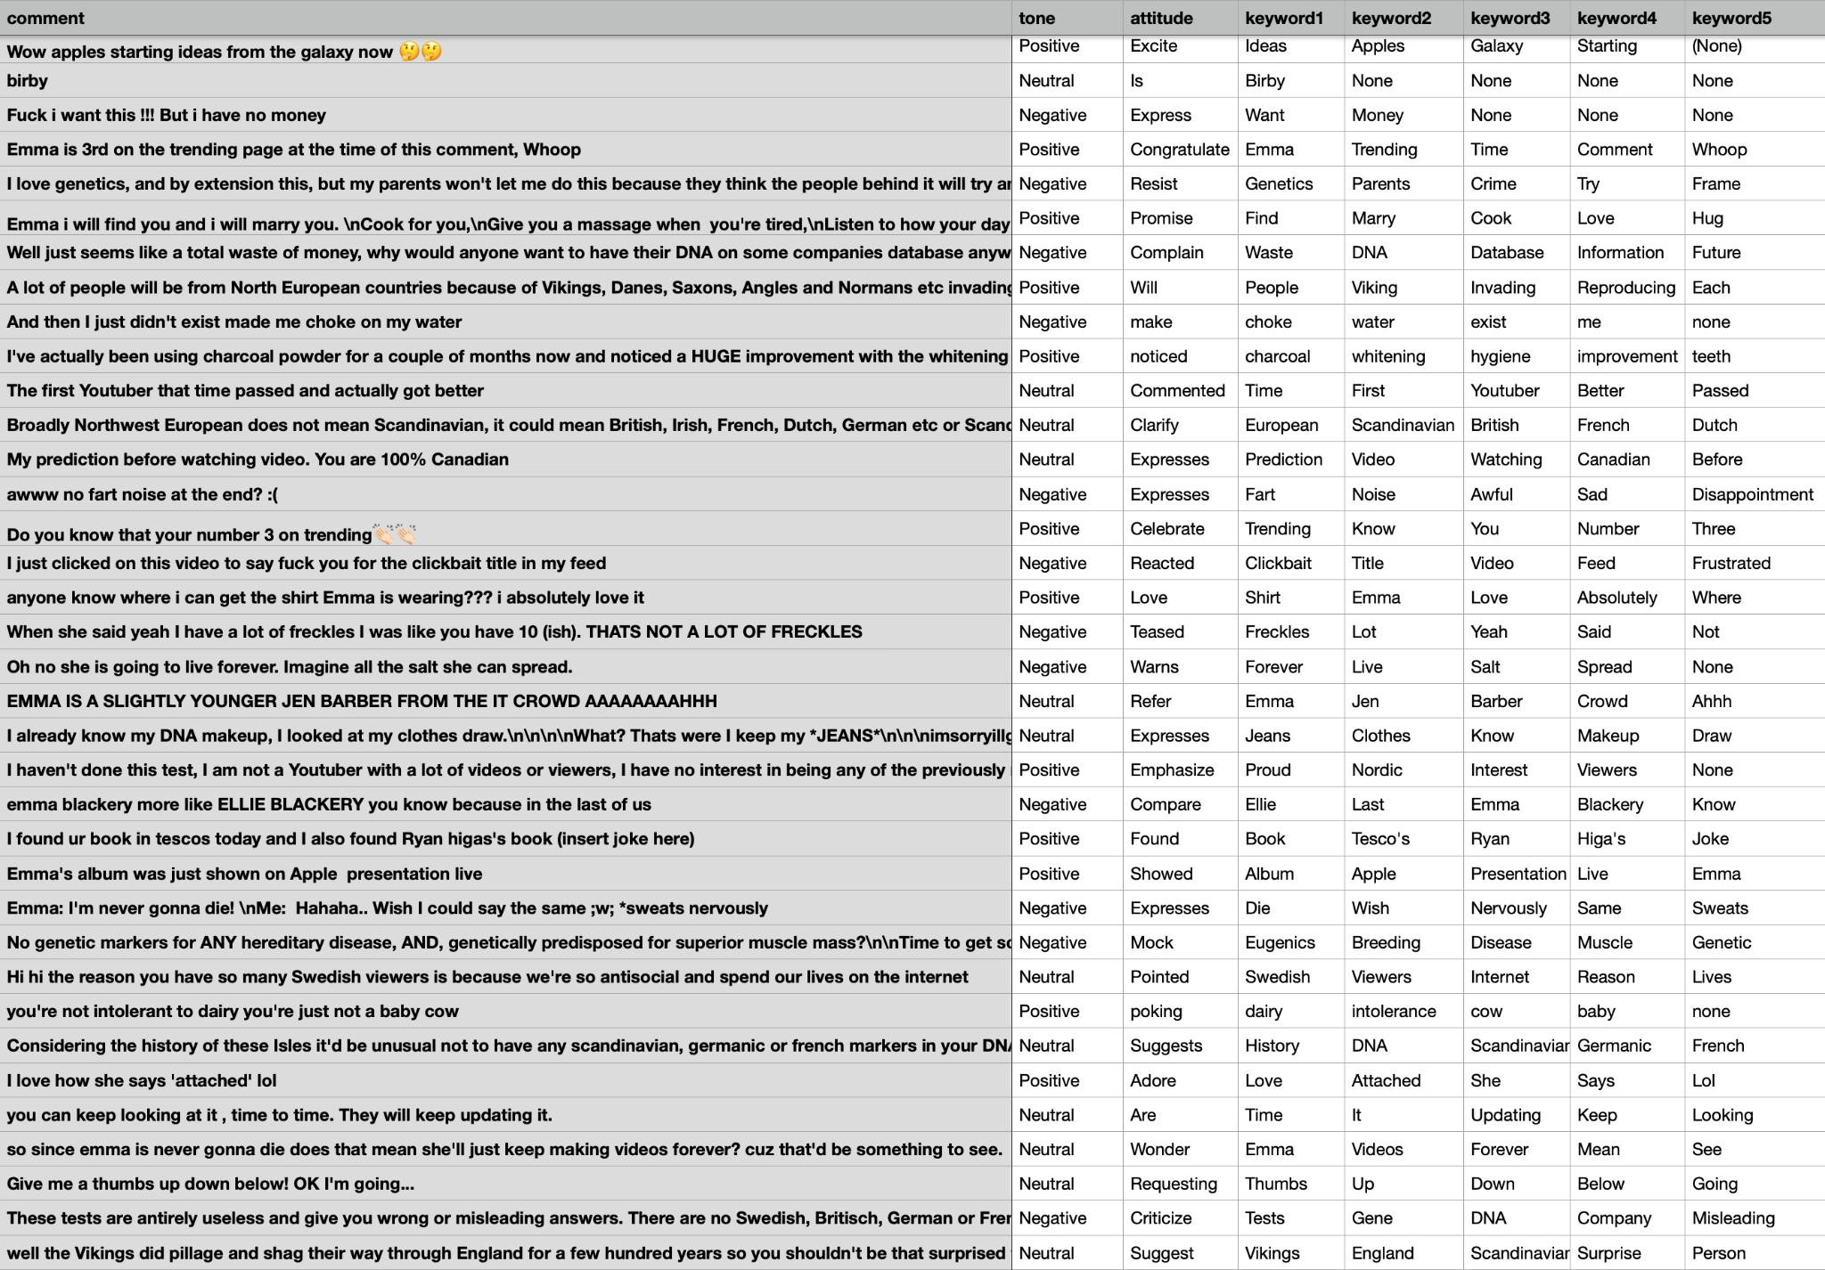

## Evaluation

* Evaluate the performance of the system relative to the project goals
* Show which methods worked and promote the methods
* Discuss data splitting for valid evaluation (e.g. train/dev/test splits)
* Define metrics and use graphs, tables, and figures to illustrate findings
* Include a baseline and comprehensive comparisons of major approaches
* 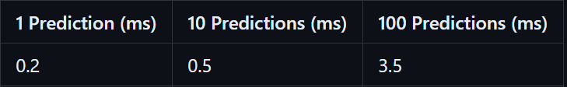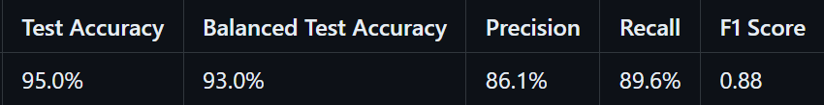

## Analysis

* Summarize and discuss the results presented in the evaluation section
* Return to the questions of "why" and "how"
* Discuss errors made by the system and their criticality

## Future Work

* Discuss shortcomings in the project and ideas for continuation
* Suggest potential next steps for the external partner

## Timeline

* Update the original schedule to reflect what actually happened
* Include a rough breakdown of who did what each week